**Opdracht 1**

lossless: compressie zonder data verlies

lossy: compressie met data verlies (herhaaldelijk bewaren maakt de kwaliteit steeds slechter)

**Opdracht 2**

Figure Boom Original (127kb)

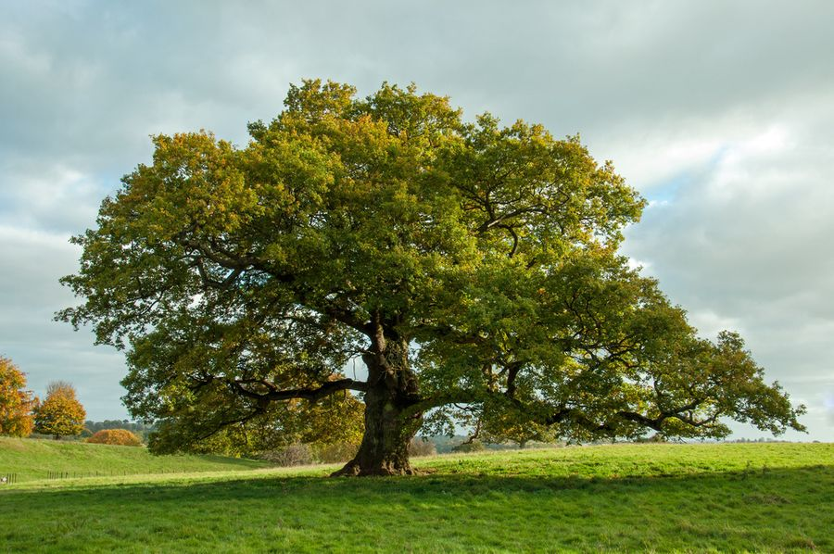

Figure Boom 90 quality factor (120kb)

Figure Boom 70 Quality factor (79kb)

Figure Boom 40 Quality factor (48kb)

Kleine details beginnen stilletjes aan verloren te gaan

**Opdracht3**

Geen fouten of warnings meer op alle 3 de pagina’s

**Opdracht4**

https://github.com/BrendCaluwe44/WebDev2022